**Bài tập lớn hệ nhúng**

**1. ESP32**

**2. Màn hình oled 1.3inch**

<https://github.com/olikraus/u8g2/wiki/u8x8reference>

https://github.com/olikraus/u8g2/wiki/setup_tutorial

**3. MAX30102**

https://microcontrollerslab.com/esp32-heart-rate-pulse-oximeter-max30102/

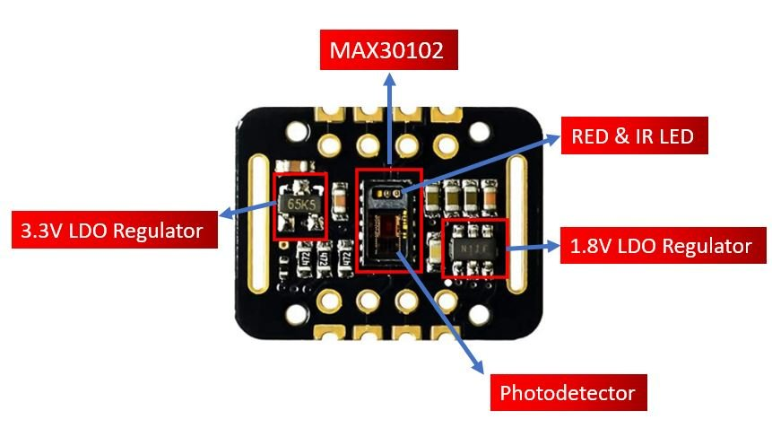

**4. RGB**

